Problem 1: Load the vitcap dataset from the ISwR package. The vitcap data frame has 24 rows and 3 columns. It contains data on vital capacity for workers in the cadmium industry.
Variables:
group: a numeric vector; group codes are 1: exposed > 10 years, 3: not exposed.
age: a numeric vector, age in years.
vital.capacity: a numeric vector, vital capacity (a measure of lung volume) in liters.
- Perform some descriptive statistics on the vital.capacity variable (mean, standard deviation, histogram, etc.)
> vitcap.hw7 <- vitcap
> vitcap.hw7
group age vital.capacity
1 1 39 4.62
2 1 40 5.29
3 1 41 5.52
4 1 41 3.71
5 1 45 4.02
6 1 49 5.09
7 1 52 2.70
8 1 47 4.31
9 1 61 2.70
10 1 65 3.03
11 1 58 2.73
12 1 59 3.67
13 3 27 5.29
14 3 25 3.67
15 3 24 5.82
16 3 32 4.77
17 3 23 5.71
18 3 25 4.47
19 3 32 4.55
20 3 18 4.61
21 3 19 5.86
22 3 26 5.20
23 3 33 4.44
24 3 27 5.52

> vitcap.hw7$group <- factor(vitcap.hw7$group, labels=c("1", "3"))
> attach(vitcap.hw7)
> summary(vitcap.hw7)
group age vital.capacity
1:12 Min. :18.00 Min. :2.700
3:12 1st Qu.:25.75 1st Qu.:3.700
Median :36.00 Median :4.580
Mean :37.83 Mean :4.471
3rd Qu.:47.50 3rd Qu.:5.290
Max. :65.00 Max. :5.860
-----------------------------------------------------------------------------------------------------------------------
> mean(vitcap.hw7$vital.capacity)
[1] 4.470833
> sd(vitcap.hw7$vital.capacity)
[1] 1.00761
> quantile(vitcap.hw7$vital.capacity)
0% 25% 50% 75% 100%
2.70 3.70 4.58 5.29 5.86
> median(vitcap.hw7$vital.capacity)
[1] 4.58

--------------------------------------------------------------------------------------------------------------------------

> hist(vitcap.hw7$vital.capacity, main = "Histogram of Vital.Capacity", col = "green")

>

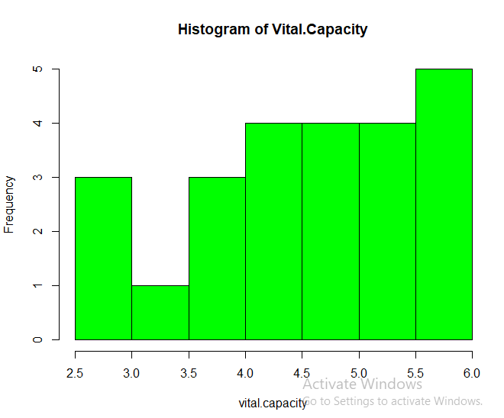

- Does the data satisfy Normality?

Yes. The data is normally distributed.

> shapiro.test(vitcap.hw7$vital.capacity)

Shapiro-Wilk normality test

data: vitcap.hw7$vital.capacity
W = 0.93014, p-value = 0.09821

The null-hypothesis (H_{o}) for this test is that the data is normally distributed.
The alternative-hypothesis (H₁) for this test is that the data is not normally distributed.

As the p-value (0.09821) is greater than the alpha level (0.05), therefore, the null hypothesis that the data is normally distributed is accepted.

- Conduct a hypothesis test to determine if the mean vital capacity for workers in the cadmium industry is significantly different than 4.7 liters.

> t.test(vitcap.hw7$vital.capacity, mu=4.7)

One Sample t-test

data: vitcap.hw7$vital.capacity
t = -1.1142, df = 23, p-value = 0.2767
alternative hypothesis: true mean is not equal to 4.7
95 percent confidence interval:
4.045357 4.896310
sample estimates:
mean of x
4.470833

As the p-value (0.2767) is greater than the alpha level (0.05), therefore, the alternative hypothesis is rejected. And conclude that the mean vital capacity is same as 4.7 ltrs.
- Graph the data to visualize the results of the hypothesis test.

> boxplot(vitcap.hw7$vital.capacity, main= "boxplot of Vital.capacity (a measure of Lung volume)", ylab= "Lung Capacity (in liters)", col = “green”)

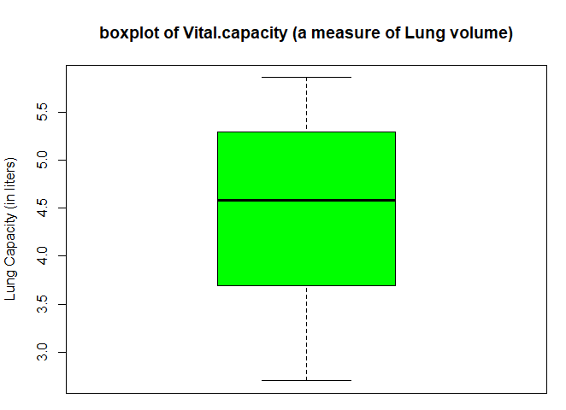

- Write a few sentences to draw thorough conclusions about the analysis

The analysis is focused on the vital capacity of lung of workers in the cadmium industry. Performing descriptive statistics, we come to know that the mean of of vital capacity is 4.471 ltrs. With a standard deviation of 1.007 ltrs. The range varies from 2.7 to 5.86 ltrs. With the median of 4.58 ltrs. The data is normally distributed and verified by performing Shapiro-Wilk normality test. As the p-value (0.09821) is greater than the level of significance (0.05), therefore, the null hypothesis that the data is normally distributed is accepted.
We can say from the t-test that the output p-value (0.2767) is greater than level of significance (0.05). Hence, we accept the null hypothesis and thus conclude that the mean vital capacity for workers in the cadmium industry is not significantly different than 4.7 liters. Also, the 95% confidence interval does contain the value 4.7.

